Simulation Assignment 2

March 3, 2019

**Abstract**

The dynamics of our V1 neurons are seemingly uncharacteristic when we employ different illusions. In this simulation assignment, we looked at generating a neural network that would respond to edges, lines of different sizes, Munker-White illusion, and the Simultaneous Contrast illusion. Ultimately, the importance comes from the ability to use these illusions in visual studies to understand how subjects perceive lightness in a non-uniform environment. What we found that as the width of a line increased, we had an increase in neuronal intensity which then subsided after we reached a certain width such that only the edges of the line had strong activation. Furthermore, our network supported the idea that it found the Simultaneous-Contrast illusion partly caused by lateral inhibition, while the Munker-White included T junctions which have been shown to contribute to the illusion of brightness.

**Introduction**

This simulation assignment ultimately centers on the differences between our spatial and temporal processing of edges and lines with varying widths and the two illusions mentioned previously. Firstly, surface reflectance is the combination of some physical properties and perceptual integration. We utilize these ideas in our application of the Simultaneous-Contrast Illusion and the Munker-White Illusion. In the Simulatenous-Contrast Illusion, two pairs of grey patches are presented with the only difference being the outside pair having a varying grey luminance. The result of this is that the internal rectangle in each pair are perceive to have a difference brightness, but they actually have the same luminance and the same brightness if the contrast stimulus is taken away. The Munker-White illusion is slightly more complex. It is a combination of horizontal alternating black and white gratings. At different places on these gratings, the white or black grating is replaced with a grey rectangle. Depending on if it is put on the white or black grating, it will be perceived darker or lighter than its counterpart respectively. What we looked at was how our neural network responded to each illusion and individual line width to shed light on both of these illusions.

**Methods**

A neuronal network of ten-thousand neurons was constructed in MATLAB R2018, in order to respond to the given stimuli. The differential equation used in this is simulation is as follows:

This equation measures the activity based on three parts: the passive decay , the shunting excitation , and the shunting inhibition . In this case an added C term is related to the Nernst potential for potassium was added to depict hyperpolarization of the cell, giving the property that can help suppress uniform inputs. The summations were added in order to fully encompass the surrounding neuronal activation and its impact on the one neuron we are looking at.

**Results**

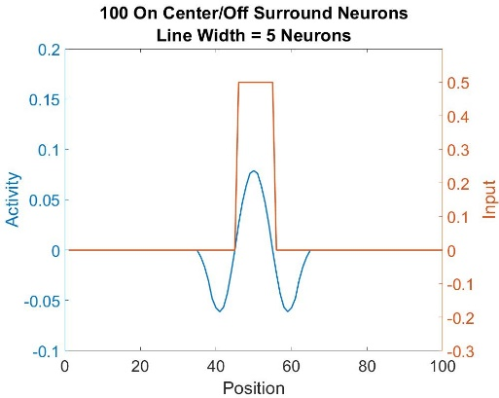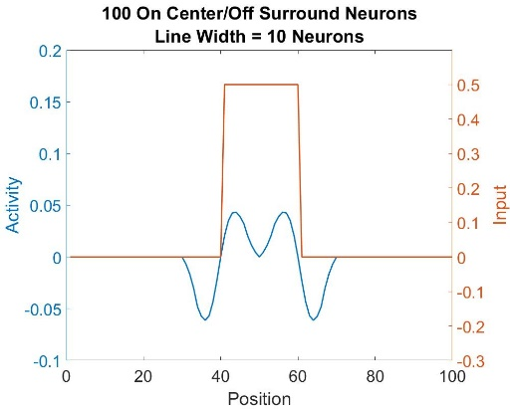

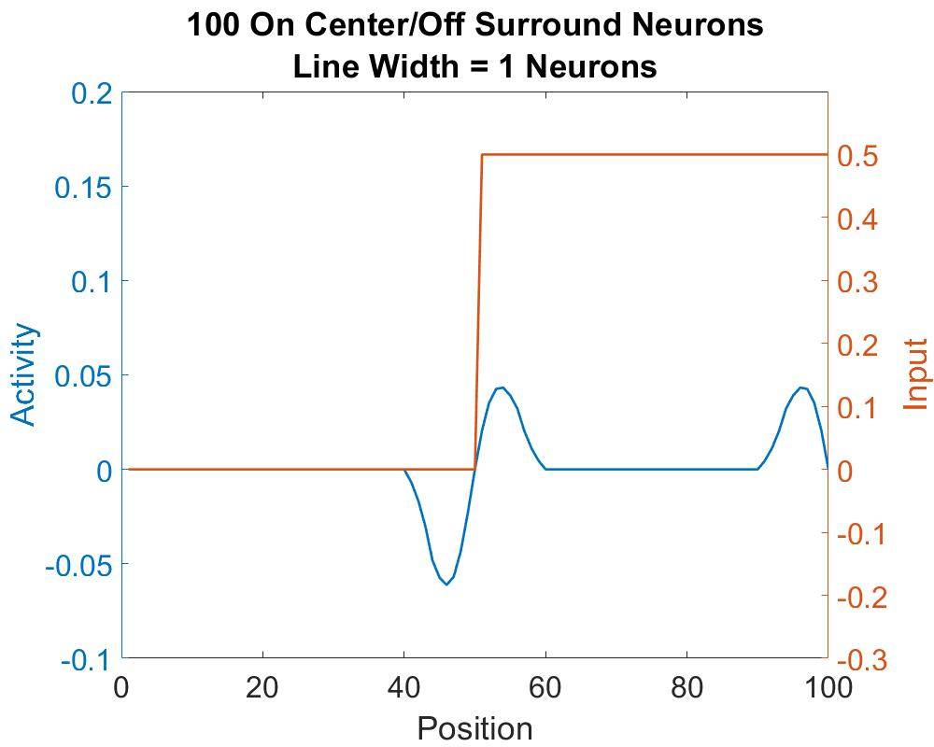

**Figure 1. On-center/Off-surround spatio-temporal responses to edge stimuli.** In the first panel, the line width is supposed to represent a simple edge response between two stimuli. In the second panel, we increase the width of the line by a few neurons, resulting in a response to a line with width x = 5. In the third panel, we have an even thicker line width where width x = 10.

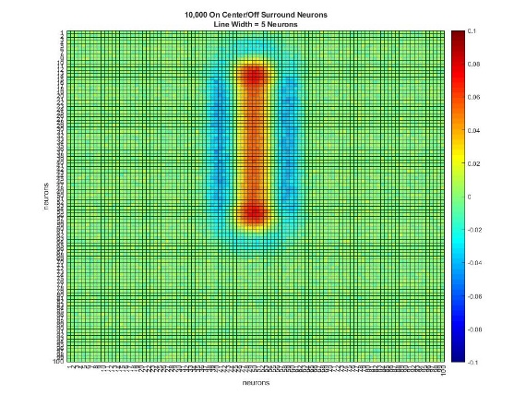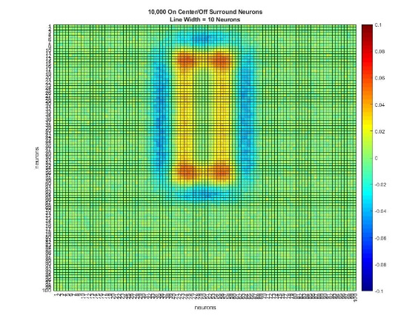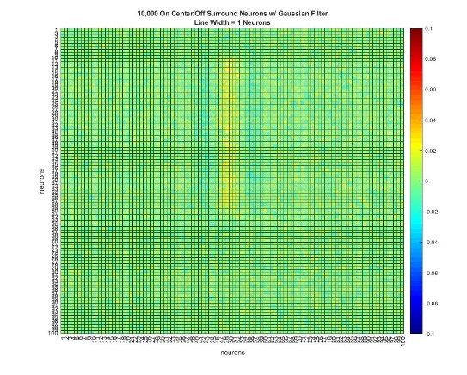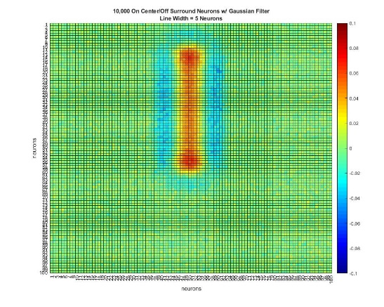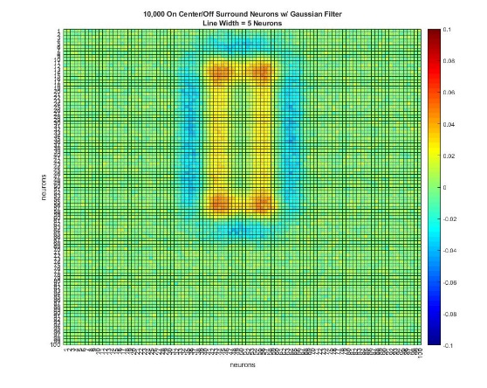

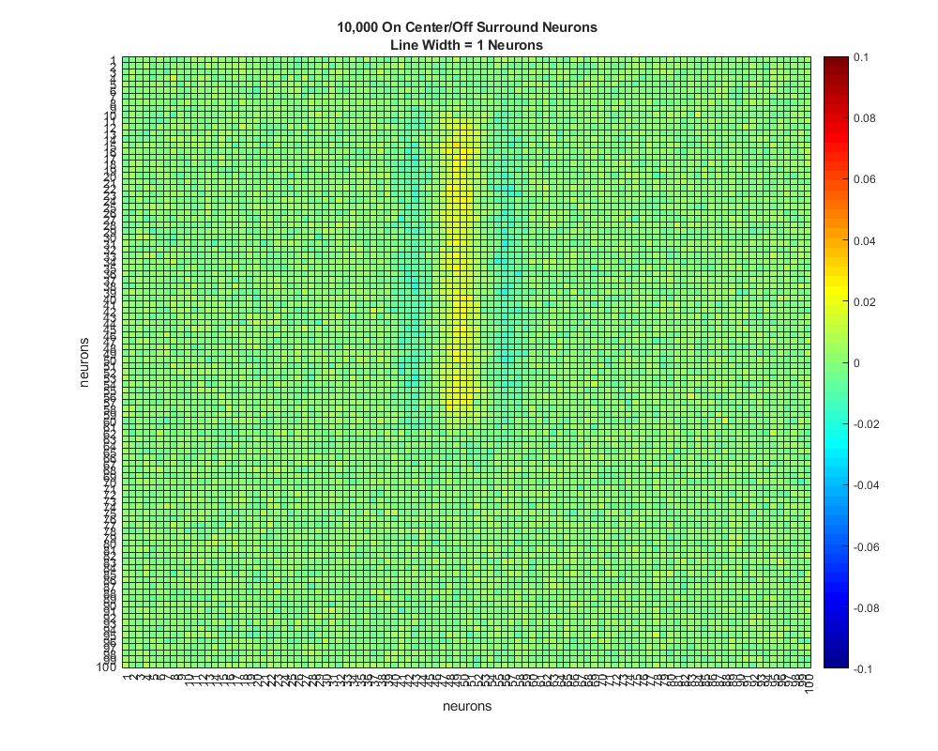

**Figure 2. 2D Responses to lines of different widths.** The top three panels are without a Gaussian filter and go from width 1, representing an edge, to the thickest line width 10. The bottom three panels include a Gaussian filter, with the same base characteristics as mentioned earlier.

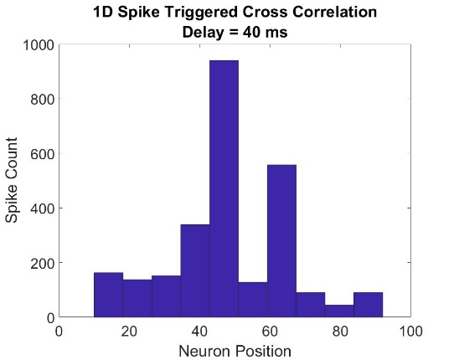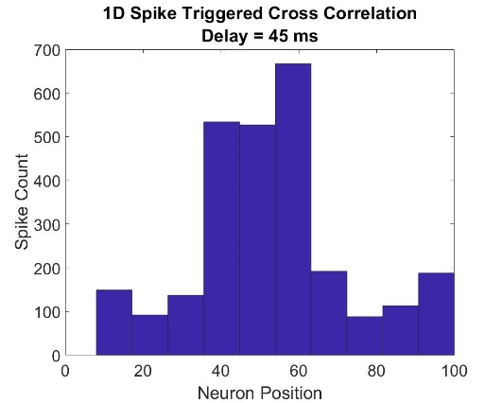

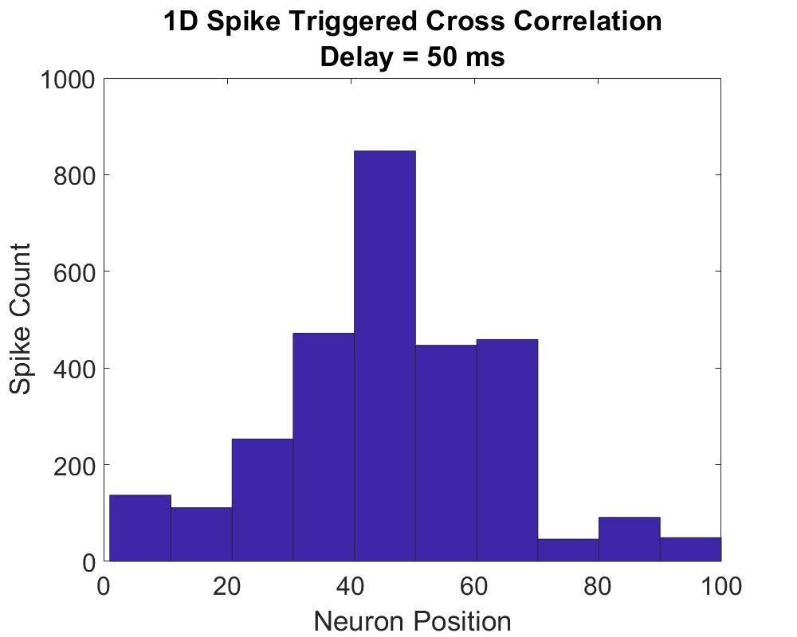

**Figure 3. 1D Spike-Triggered Cross Correlation Delay.** In the first panel we have a 40ms delay for the spike triggered correlation, which shows a big spike where the edge stimulus of a line would be at neuron position 45 and another high spike count at 65. The second panel shows the position 5ms later with a more uniform distribution. Finally, in the third panel after 50ms delay we have a relative stabilization of the spike train.

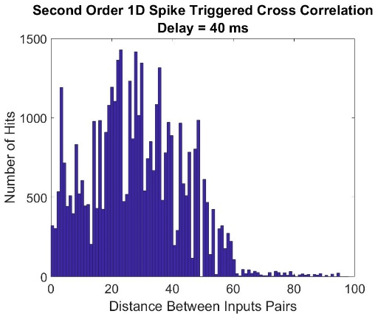

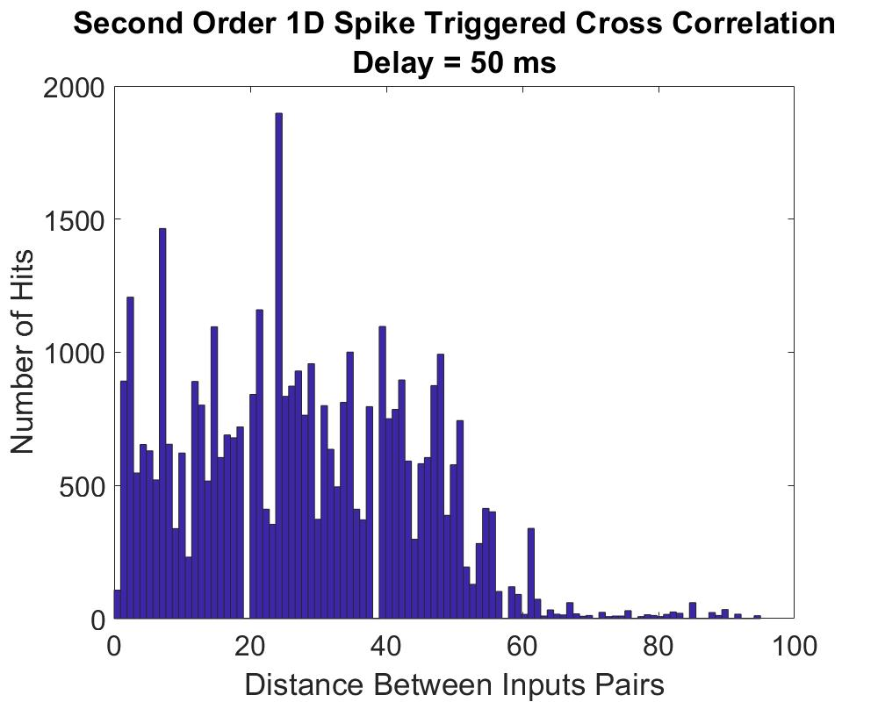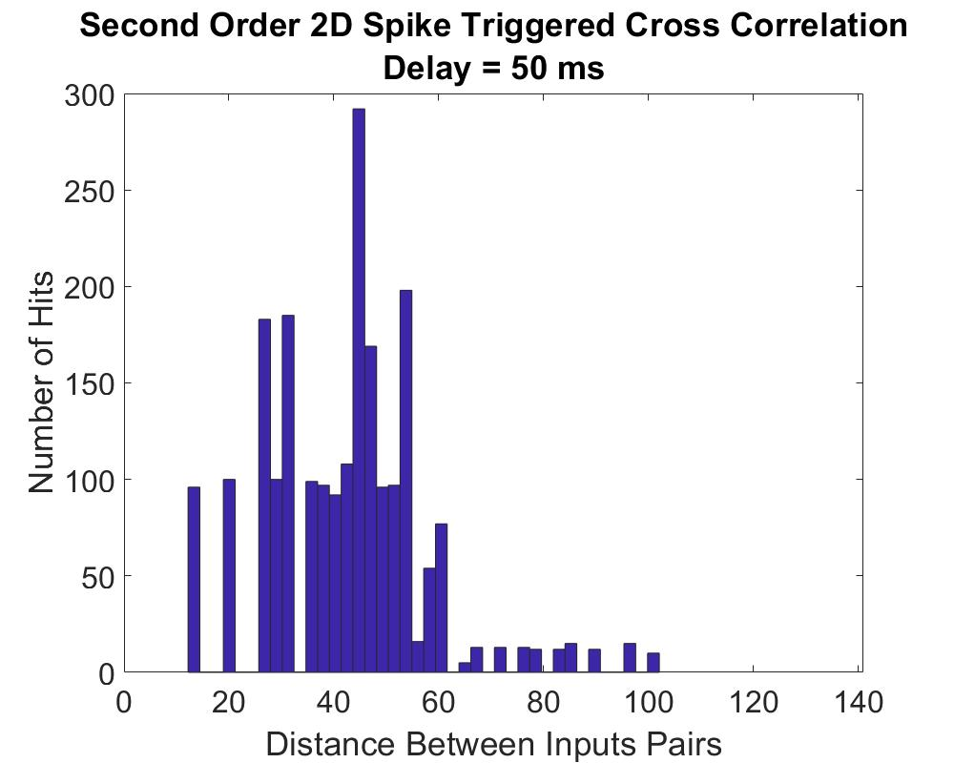

**Figure 4. Second Order Spike Triggered Cross Correlation Delay.** In panel A, we see that the distances between input pairs at a 40ms delay have a uniform distribution. In panel B, we see that at a 50ms delay, we one specific distance having the highest spike count. Finally, when we take the 2D spike cross correlation, we see that the receptive field of the neuron is primarily around position 45 with highest spike count.

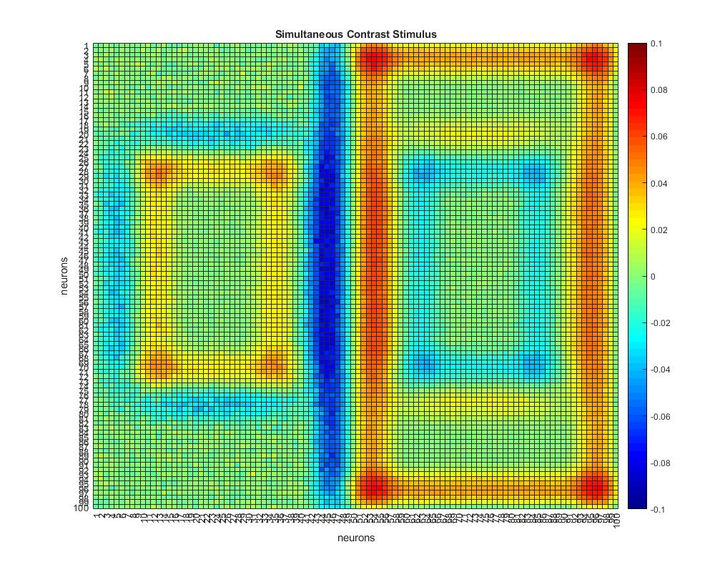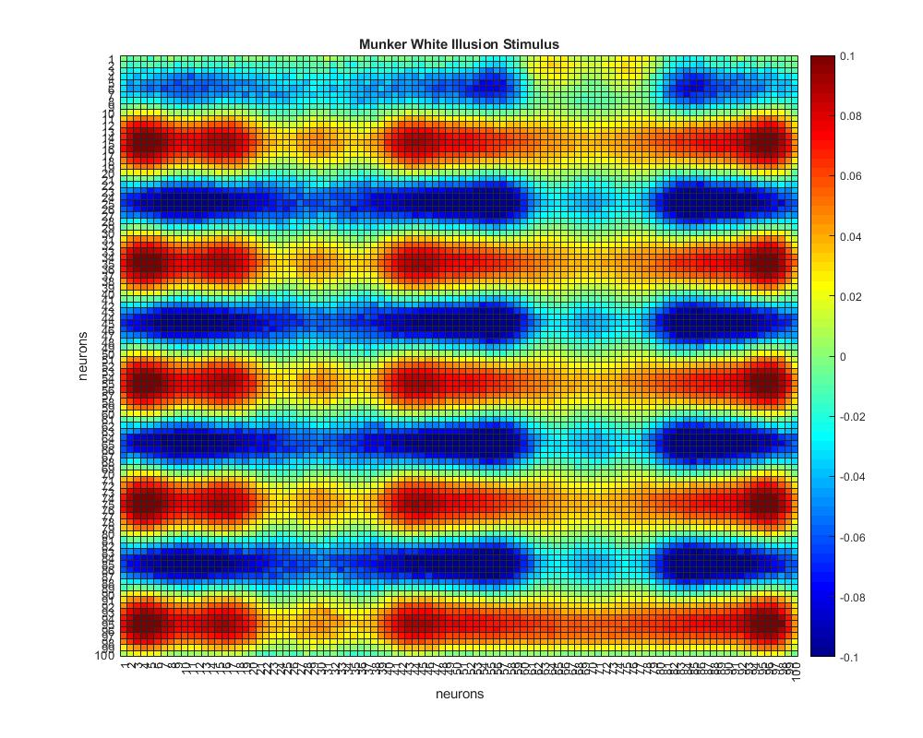

**Figure 5. Simultaneous-Contrast vs Munker-White illusion.** In the first panel we have a comparison between two simultaneous contrast stimuli impacts on neuronal activation. The second panel represents the neuronal activation during the Munker-White Illusion.

**Discussion.**

**1a-b.** When the 1D network was generated, what we see in the spatio-temporal response is that an edge will elicit a negative activity level before the edge, and then a positive one immediately after. In the first panel of figure 1, we see that an edge will be the only thing that elicits a response. However, one the edge becomes a line with a certain thickness, the level of activation begins to differ. In the second panel in figure 1, we see that when the width is increased, we have a positive parabolic activation on the inside, but a negative on the outside, resulting in an on-center, off surround. Then what is interesting is that when we begin to increase the line width even more, it begins to take the shape of a rectangle. So what our neuronal model begins to perceive is just the combination of edges at the beginning and end of the width of the triangle. Consequently, this tells us that there is a perceived off surround when we fill in a uniform surface that does not have any edges anymore. We can hypothesize that as the width of a “line” increases, the more we see it as a shape with a uniform filling and edges. Therefore, our neuronal network will only activate to the edges of the line.

**1d-e.** Based on figure 2, the difference between the functions is not particularly apparent. The surface response of the network is as expected based on our 1D network in figure 1. We see that in the top three panels that we get a response to an edge, and then a significant response to a slightly thicker line. Then, when the thickness is increased to a point where it begins to take a rectangle shape, the neurons primarily activate around the edges as seen by the heat map. This suppression of the response to a uniform surface is especially apparent in panel 3 of figure 2. Therefore, our neuronal network corresponds to our V1 cells such that they will respond to edges, but when a shape begins to form, the neurons will respond to the edges of the shape.

**2a-b.** Based on figure 3, we can see that at different times the spike interval correlation diagram will have different peaks. However, in panel 3 we can see that after 50ms the receptive field levels out and shows a specific peak. The importance of this is that we can see at what position the neurons most fired, resulting in the creation of receptive field. We can obtain the full spatio-temporal response of all model neurons by recording from only one neuron if we simply shift the image itself around the neuron or the neuron around the image. Then the average of those responses can be taken based on the position.

**2c-d.** In panel 1-3 of Figure 4 we see that as the distance increases, the amount of spikes decreases. This is similar to the end-stopping property seen in actual V1 neurons because we see the decrease in response. In panel 3 of figure 4, we still see the receptive field of the neuron, but with included end-stopping property. Consequently, this shows that the neurons will stop responding as the length of the antagonistic region increases. In addition, end-stopping is seen in panel 3 of figure 2 where the heat map shows dense neuronal activity at each corner. This supports the idea that an optimal stimulus to see the end-stopping property in V1 neurons is corners.

**3a-b.** Ultimately, the simulation assignment concludes in figure 5 which is the culmination of the observations we have seen earlier. Firstly, simultaneous contrast is present in both the first panel and during the Munker White illusion. However, what is different here is that lateral inhibition is the main driver in the simultaneous contrast illusion. In the Munker White we can somewhat allude to the anchoring theory in lightness perception. Where we have our theoretical value of belongingness and a weighting of each of environmental frameworks to somehow explain this illusion.

**Conclusion**

Overall, this simulation assignment showed a few of the properties that our V1 cells have. As the width of a line increases, we have a suppression of the uniform surface, but activation around the edges. Our spike-interval-correlation diagrams showed that V1 cells do exhibit end-stopping. Finally, the differences between the Munker-White and the Simultaneous Contrast Illusions were looked at. Within those boundaries, the Munker-White illusion takes on a new level of difficulty in explanation as it seems to employ multiple facets of our perceptual abilities.